Supply List

Dear Parents,

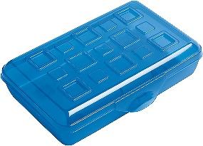 There will be no sharing of supplies once we are in school. Each child should have their own:

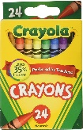Pencil case

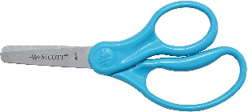1 box of crayons

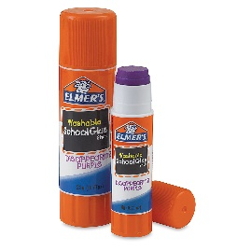Scissors

2 Glue sticks (Elmer’s Disappearing Purple is the best)

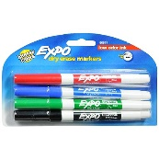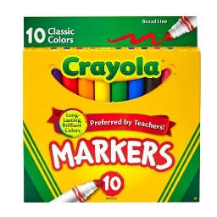Markers

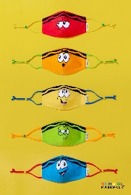 2 Expo markers (any size/color)

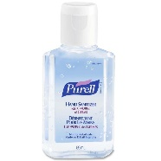Mini hand sanitizer

Extra Mask

Everything should be **clearly labeled.**

I will supply each child with a plastic folder, white board and their own pencils for the year.